Programing Fundamental

3rd Assignment

Session: 1E

Name:

Sabir Hussain

Roll no:

BCSM-f19-262

Pro: Umair Ahmad

**Problem set 1**

1. **Write a program that stores 10 numbers in an array and find the max no among those ten.**

**Program:**

#include<iostream>

#include<conio.h>

using namespace std;

int main ()

{

int arry [10], max_no;

max_no=arry [0];

for (int i=0; i<10; i++)

{

cout<<"Enter no. "<<i+1<<" = ";

cin>>arry[i];

if(arry[i]>max_no)

max_no=arry[i];

}

cout<<endl<<endl;

cout<<"Greater no. from {";

for (int n=0; n<10; n++)

{

cout<<arry[n];

if (n! = 9)

cout<<",";

}

cout<<"} = "<<max_no;

getch ();

return 0;

}

**Output console:**

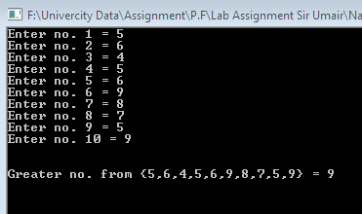

1. **Read the entries of an array of 10 integers from a user. Compute x as the average of the10 entries and then compute the average of those entries that are greater than or equal to x. Print this final average.**

**Program:**

**#include<iostream>**

**#include<conio.h>**

**using namespace std;**

**float x;**

**int main ()**

**{**

**float arry [10], sum=0;**

**for (int i=0; i<10; i++)**

**{**

**cout<<"Enter no. "<<i+1<<" = ";**

**cin>>arry[i];**

**sum+=arry[i];**

**}**

**x=sum/10.0;**

**cout<<endl<<endl;**

**cout<<"Avg. of 10 no. = "<<x;**

**cout<<endl;**

**float sum1=0, avg, n=0;**

**cout<<"Avg of {";**

**for (int j=0; j<10; j++)**

**{**

**if(arry[j]>=x)**

**{**

**n++;**

**cout<<arry[j];**

**cout<<",";**

**sum1+=arry[j];**

**}**

**}**

**cout<<"} = "<<(sum1/n);**

**getch ();**

**return 0;**

**}**

**Output console:**

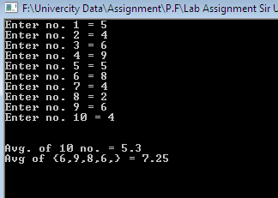

1. **Write a C++ program to find second largest element in an array.**

**Program:**

**#include<iostream>**

**#include<conio.h>**

**using namespace std;**

**int main ()**

**{**

**int arry [10], max_1no, max_2no;**

**max_1no=arry [0];**

**for (int i=0; i<10; i++)**

**{**

**cout<<"Enter no. "<<i+1<<" = ";**

**cin>>arry[i];**

**if(arry[i]>max_1no)**

**{**

**max_2no=max_1no;**

**max_1no=arry[i];**

**}**

**}**

**cout<<endl<<endl;**

**cout<<"Arry element = {";**

**for (int n=0; n<10; n++)**

**{**

**cout<<arry[n];**

**if (n! = 9)**

**cout<<",";**

**}**

**cout<<"}";**

**cout<<endl;**

**cout<<"1st Greater no. in Arry = "<<max_1no;**

**cout<<"\n2nd Greater no. in Arry = "<<max_2no;**

**getch ();**

**return 0;**

**}**

**Output console:**

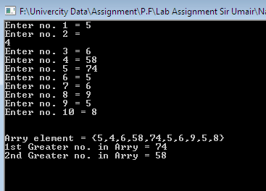

**Problem set 2**

1. **Write a C++ program to merge two arrays to third array using user defined function.**

**Program:**

**#include<iostream>**

**#include<conio.h>**

**using namespace std;**

**void arry_input (int arry []);**

**void arry_output (int arry []);**

**int main ()**

**{**

**int arry1[5], arry 2[5], marge [10];**

**cout<<"Enter 5 Elements in 1st Array\n";**

**arry_input(arry1);**

**cout<<"\n Enter 5 Elements in 2nd Array\n";**

**arry_input(arry2);**

**for (int i=0; i<5; i++)**

**{**

**marge[i]=arry1[i];**

**marge[i+5] =arry2[i];**

**}**

**cout<<"\n\n Elements of Array After Merge\n";**

**cout<<"Merge Array = {";**

**arry_output(marge);**

**cout<<"}";**

**getch ();**

**return 0;**

**}**

**void arry_input (int arry [])**

**{**

**for (int i=0; i<5; i++)**

**{**

**cout<<"Enter element no. "<<i+1<<" = ";**

**cin>>arry[i];**

**}**

**}**

**void arry_output (int arry [])**

**{**

**For (int i=0; i<10; i++)**

**{**

**cout<<arry[i];**

**if(I !=9)**

**{**

**cout<<",";**

**}**

**}**

**}**

**Output console:**

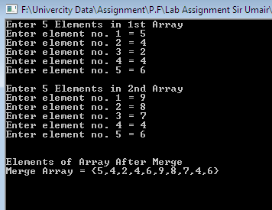

1. **Write a program that asks the user to enter an integer. Convert the integer to individual digits and store them to an array i.e. one digit on one index position and prints that. And then checks whether that number is a palindrome or not. Palindrome is a number that is read same from L to R and R to L. For e.g. 2345432 is palindrome so is 123321 where as 1234567 is not.**

**Program:**

**#include<iostream>**

**#include<conio.h>**

**using namespace std;**

**int main ()**

**{**

**int num, d, digit, rev=0;**

**cout<<"Enter any Integer number = ";**

**cin>>num;**

**cout<<"Enter no. of digits in "<<num<<" = ";**

**cin>>d;**

**int loop=d, n=num;**

**int arry[d];**

**while(num>0)**

**{**

**digit=num%10;**

**rev= (rev* 10) +digit;**

**arry[d-1] =digit;**

**num/=10;**

**d--;**

**}**

**cout<<"\n\n Array = {";**

**for (int i=0; i<loop; i++)**

**{**

**cout<<arry[i];**

**if(I !=loop-1)**

**{**

**cout<<",";**

**}**

**}**

**cout<<"}";**

**if(n==rev)**

**cout<<endl<<n<<" is Palindrome";**

**else**

**cout<<endl<<n<<" is not Palindrome";**

**getch ();**

**return 0;**

**}**

**Output console 1:**

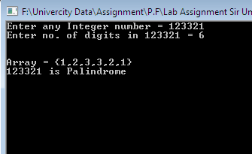

**Output console 2:**



1. **Write a C+ program to search an element in an array using user defined function.**

**Program:**

**#include<iostream>**

**#include<conio.h>**

**using namespace std;**

**int main ()**

**{**

**int arry [] = {2,3,5,7,9,10,15,20,25,27,30,35};**

**int num, loc=-1;**

**cout<<"Enter any number to find = ";**

**cin>>num;**

**for (int i=0; i<12; i++)**

**{**

**if(arry[i]==num)**

**loc=i;**

**}**

**if(loc==-1)**

**cout<<"\n value not found in the arry";**

**else**

**{**

**cout<<"\n value found in the arry"<<endl;**

**cout<<"At Index "<<loc;**

**int index;**

**cout<<"\n To check value enter same index = ";**

**cin>>index;**

**cout<<arry[index];**

**}**

**getch ();**

**return 0;**

**}**

**Output console:**

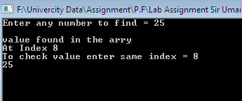

1. **Write a C+ program to sort array elements in ascending or descending order.**

**Program:**

**#include<iostream>**

**#include<conio.h>**

**using namespace std;**

**void output (int arry []);**

**void dis_sort (int arry []);**

**int main ()**

**{**

**int arry [5];**

**for (int i=0; i<5; i++)**

**{**

**cout<<"Enter Element no."<<i+1<<" = ";**

**cin>>arry[i];**

**}**

**cout<<"Value before sorting\n ";**

**output(arry);**

**dis_sort(arry);**

**cout<<"\n\n The Descending sorted array\n";**

**output(arry);**

**getch ();**

**return 0;**

**}**

**void output (int arry [])**

**{**

**for (int i=0;i<5;i++)**

**{**

**cout<<arry[i];**

**cout<<" ";**

**}**

**}**

**void dis_sort (int arry [])**

**{**

**int min, temp;**

**for (int i=0; i<4; i++)**

**{**

**min=i;**

**for (int j=i+1; j<5; j++)**

**{**

**if(arry[j]>arry[min])**

**min=j;**

**}**

**if (min!=i)**

**{**

**temp=arry[i];**

**arry[i]=arry[min];**

**arry[min]=temp;**

**}**

**}**

**}**

**Output console:**

